**Unit 1: Basic Terms, Constructions, & Transformations**

**Assignments**

**NOTE: You should be prepared for daily quizzes.**

|  |  |  |
| --- | --- | --- |
| **Day** | **Date** | **Assignment** (Due the next class meeting) |
| Monday  Tuesday | 8/12/13 (A)  8/13/13 (B) | *Pay Lab Fee $4*  *Bring tissue*  Notes: 1.1  **HW: 1.1 Worksheet** |
| Wednesday  Thursday | 8/14/13 (A)  8/15/13 (B) | *Did you turn in your syllabus and pay your lab fee?*  Notes: 1.2  **HW: 1.2 Worksheets** |
| Friday Monday | 8/16/13 (A)  8/19/13 (B) | *Did you turn in your syllabus and pay your lab fee?*  Notes: 1.3  **HW: 1.3 Worksheet** |
| Tuesday  Wednesday | 8/20/13 (A)  8/21/13 (B) | *Did you turn in your syllabus and pay your lab fee?*  Notes: 1.4  **HW: 1.4 Worksheet** |
| Thursday  Friday | 8/22/13 (A)  8/23/13 (B) | *Did you turn in your syllabus and pay your lab fee?*  Notes: 1.5  **HW: 1.5 Worksheet** |
| Monday  Tuesday | 8/26/12 (A)  8/27/12(B) | *Did you turn in your syllabus and pay your lab fee?*  Notes: 1.6 (*If needed*)  **HW: Unit 1 Practice Test** |
| Wednesday  Thursday | 8/28/13 (A)  8/29/13 (B) | ***UNIT 1 TEST*** |

HW reminders:

* If you cannot solve a problem, get help **before** the assignment is due.
* Help is available before school, during lunch, or during IC.
* For extra practice, visit [www.interactmath.com](http://www.interactmath.com)

** Name: ___________________**

**1.1 Homework**

**Use the figure at the right to name examples of each term**.

1. Three points 2. Two lines

3. Three Rays 4. Three segments

5. Point that is not on $\overline{AD}$ 6. Line that does not contain point E

7. Ray with point $A$ as its 8. Segment with point $E$ and F as

endpoint. its endpoints

9. Three collinear points 10. Three non-collinear points

**Refer to the figure below to answer questions #11-14**.

 11. Name the intersection of plane and plane

12. Name the intersection of plane and plane

13. Name two planes that intersect in .

14. Name two planes that intersect in $\overset{⃡}{EF}$.

**Determine whether the following statements are true or false.**

15. If two lines intersect in a point, then the point is in both lines. ___________

16. More than one line can be drawn through two points. ___________

17. Two planes can intersect in a line. ___________

18. Two points determine two lines. ___________

19. Three non-collinear points determine a plane. ___________

20. If two planes intersect in a line, then the line is in both planes. ___________

21. It is possible for two lines to line in the same plane. ___________



A

C

E

G

I

K

***For #22-23, use the line to find each measure.***

22. If AC = 10 and CG = 21, find AG. 23. If AI = 72 and GI = 11, find AG.

***For #24-25, use the figure at the right.***

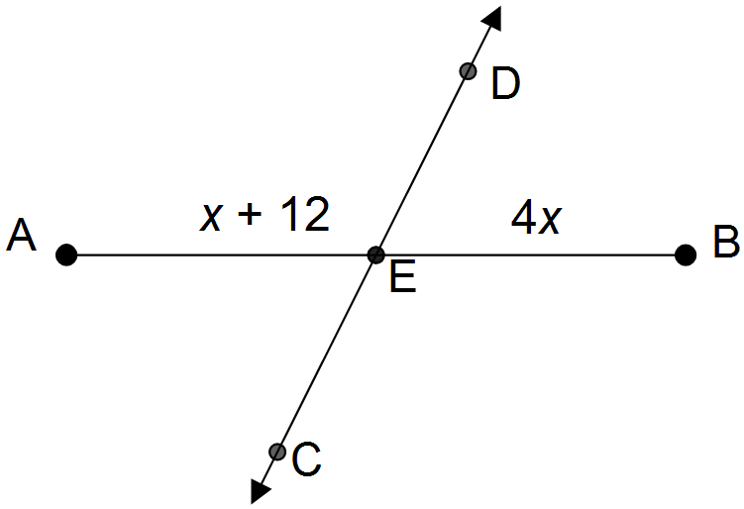

24. Find the value of .

25. Find the measure of .

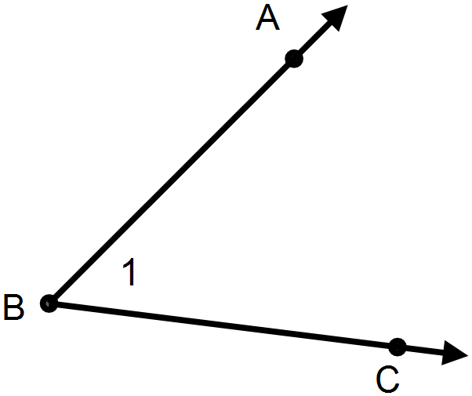

26. Name this angle in as many ways as you can.

(using letters, numbers, etc.)

***Use the diagram below to answer questions #27-29.***

27. If , does bisect ?



28. If bisects, find the measure of .

29. If bisects, find the measure of .

30. bisects ∠ $RAD$. If $m∠CAD=51°$ and $m∠RAD=(7x-3)°$, find the value of x. (Draw a

picture)

Name __________________________

**1.2 Homework**

***#1-2: Construct a line segment with the same length as each given line segment.***

1. 2.

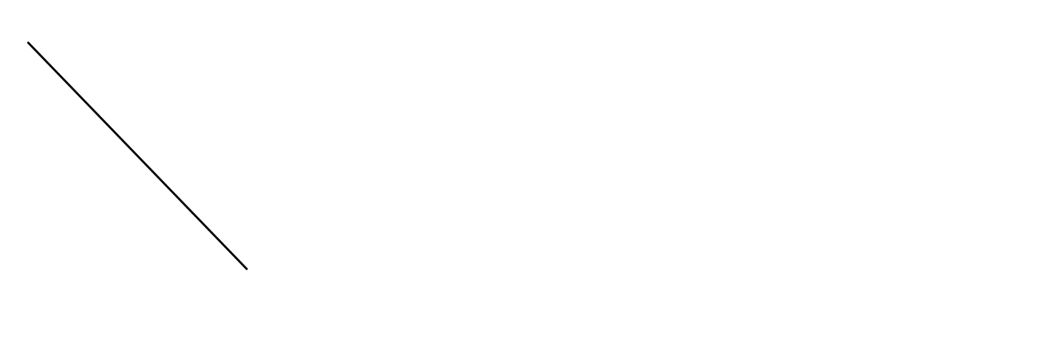

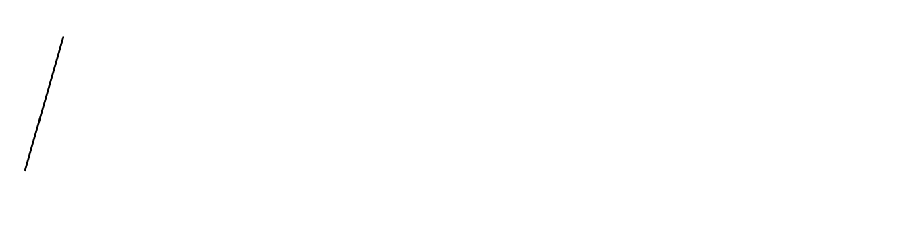

***#3-4: Construct a bisector for each given line segment.***

3. 4.

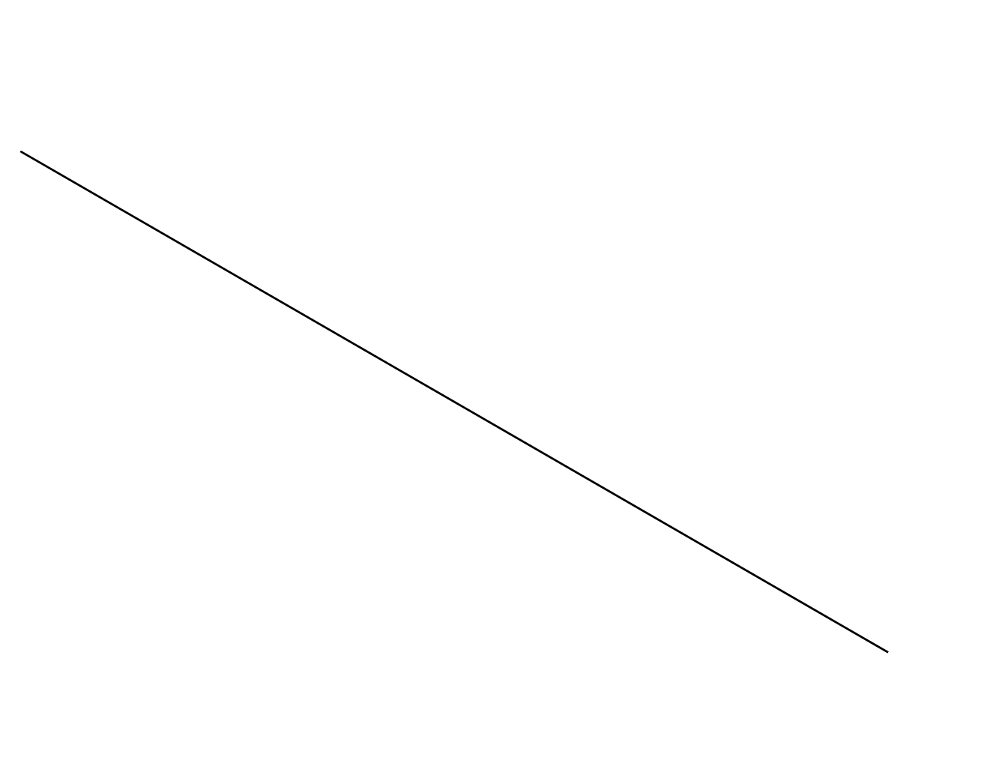

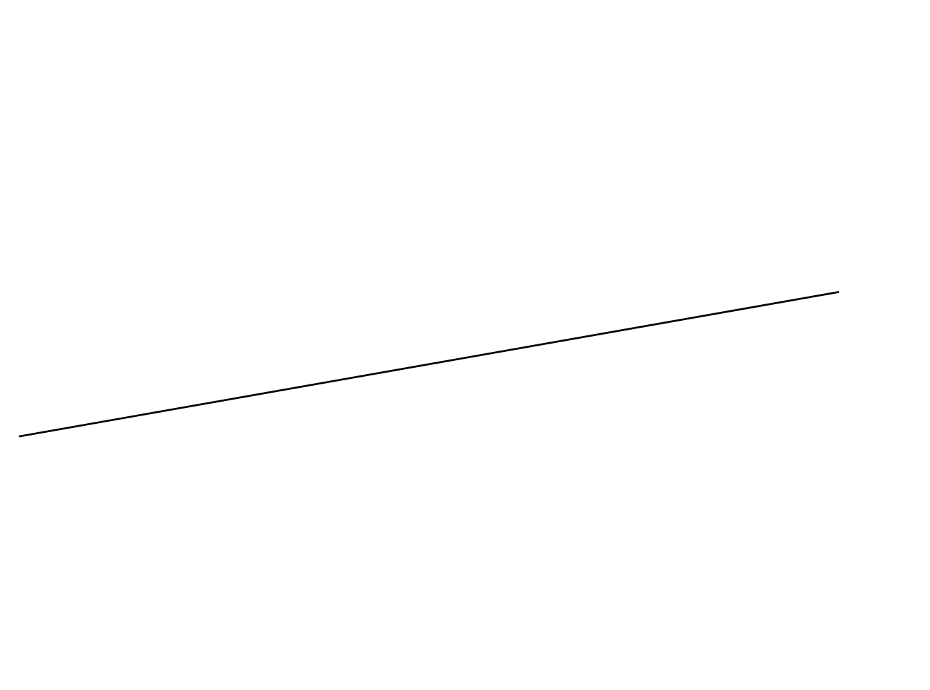

***#5-6: Construct a line that is perpendicular to the give line, passing through the given point.***

5. 6.

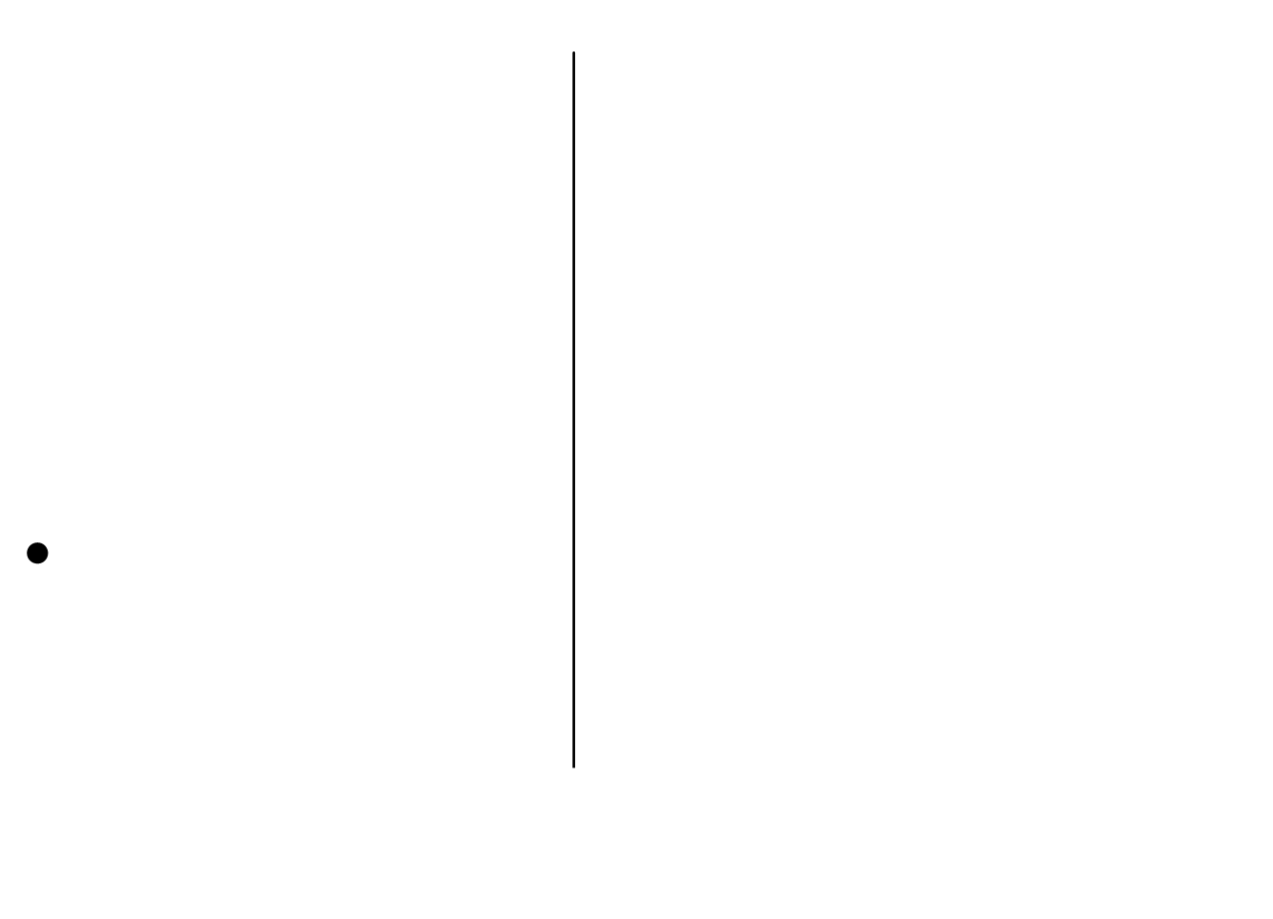

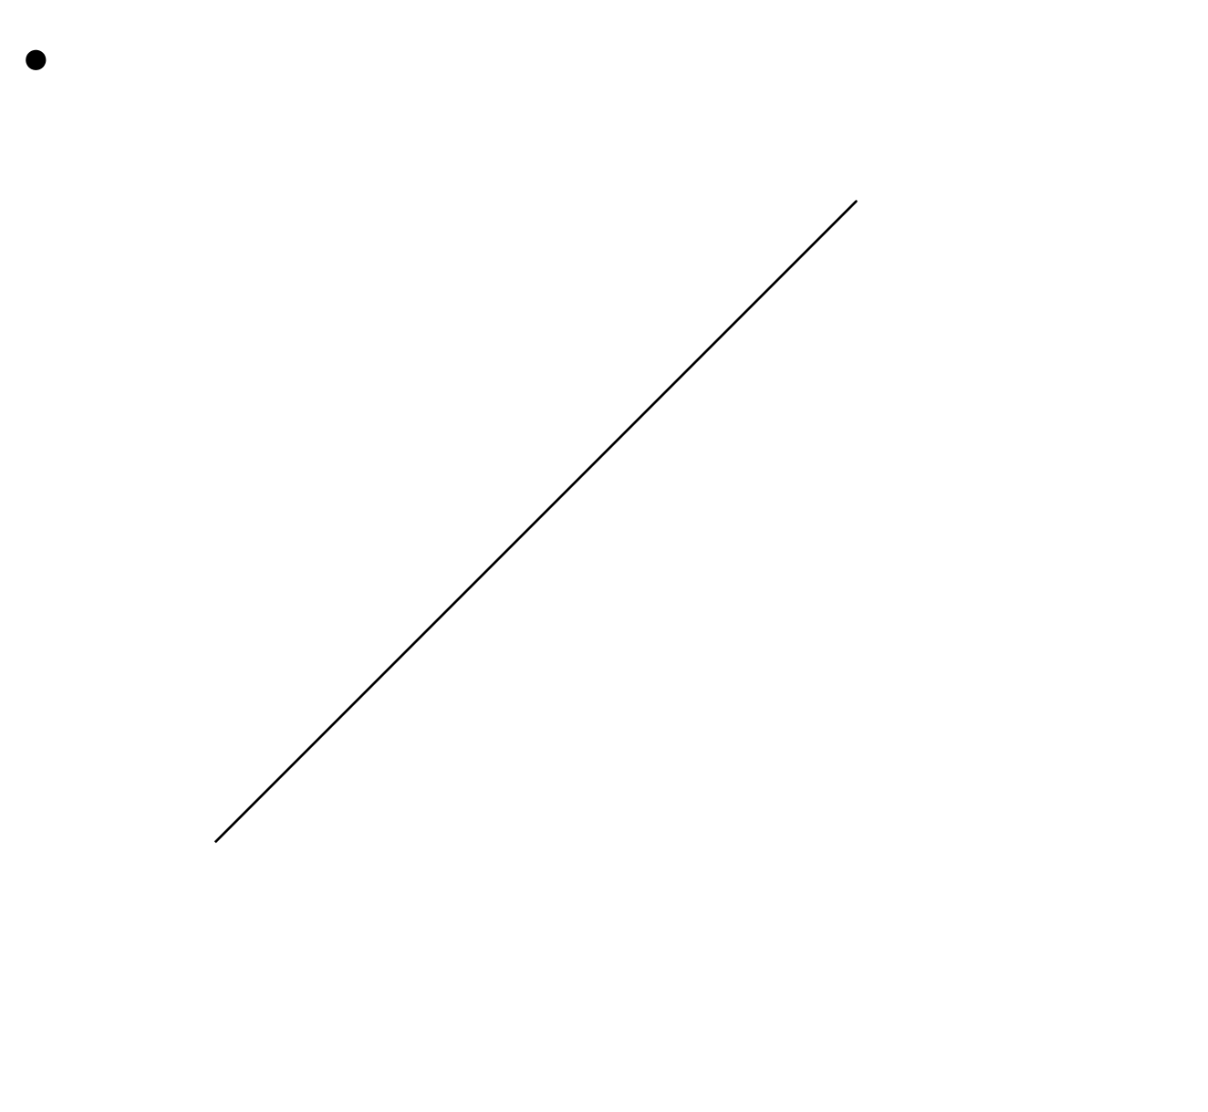

***#7-8: Construct a copy of each given angle.***

7. 8.

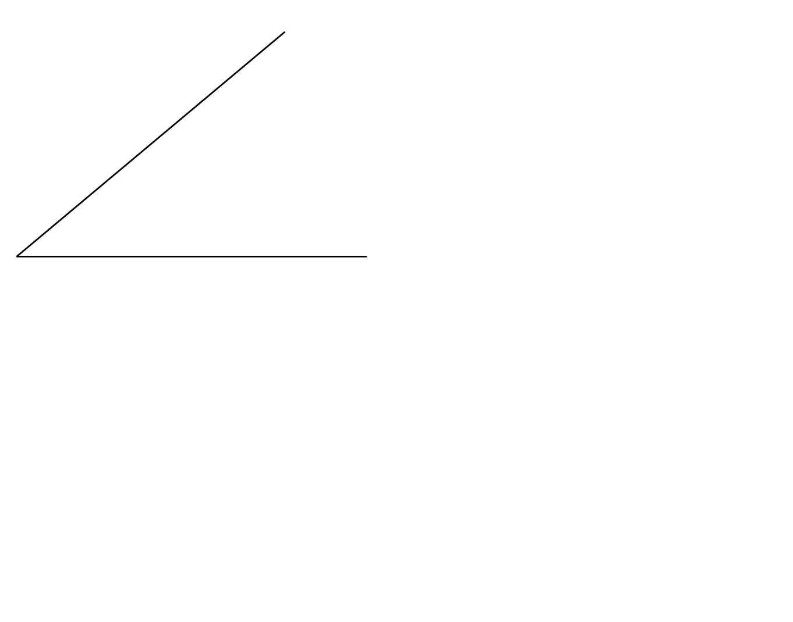

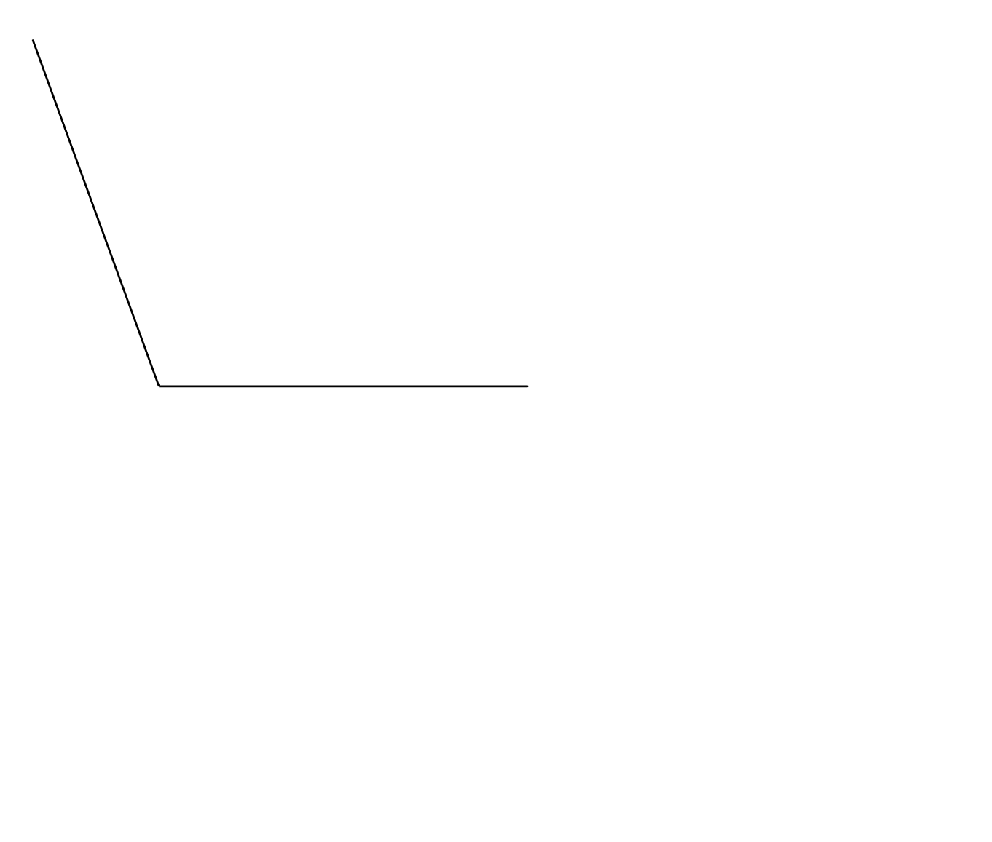

***#9-10: Construct a bisector of each angle.***

9. 10.

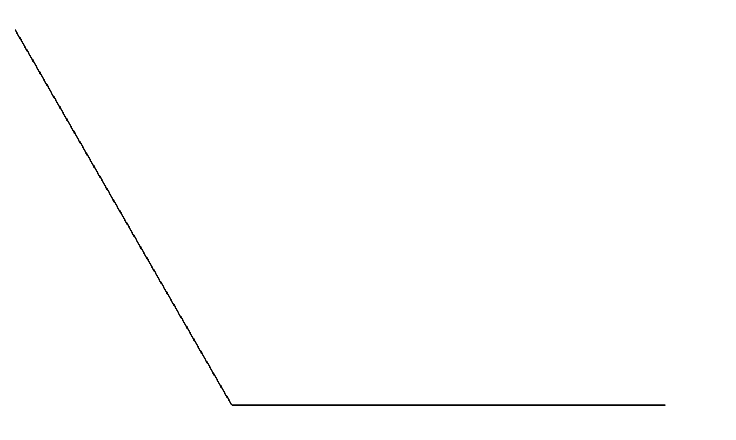

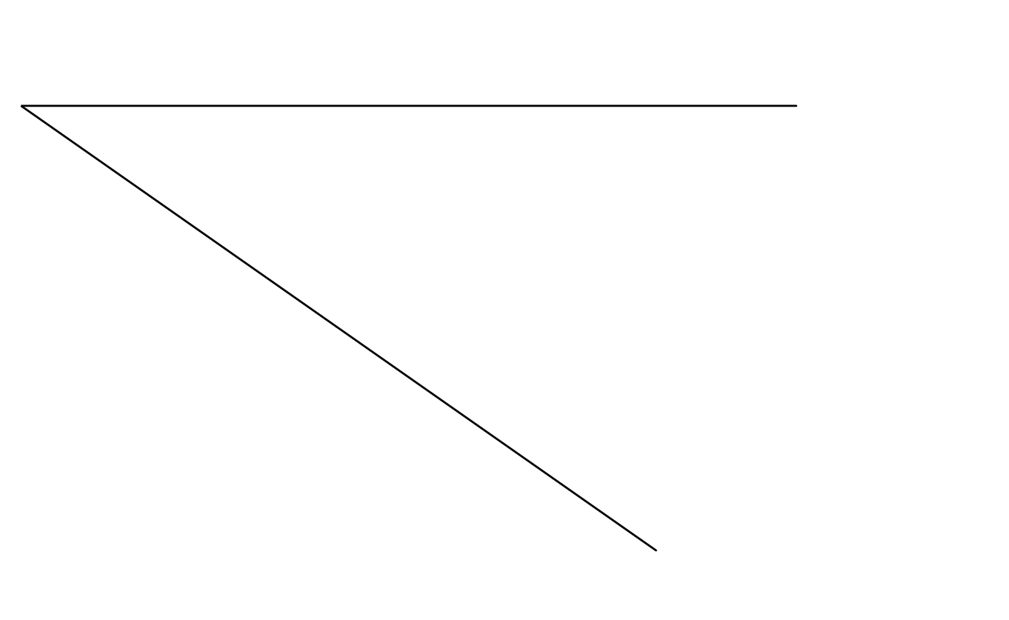

***#11-12: Construct a circle with the given radius.***

11. 12.

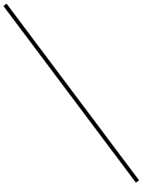



***REVIEW***

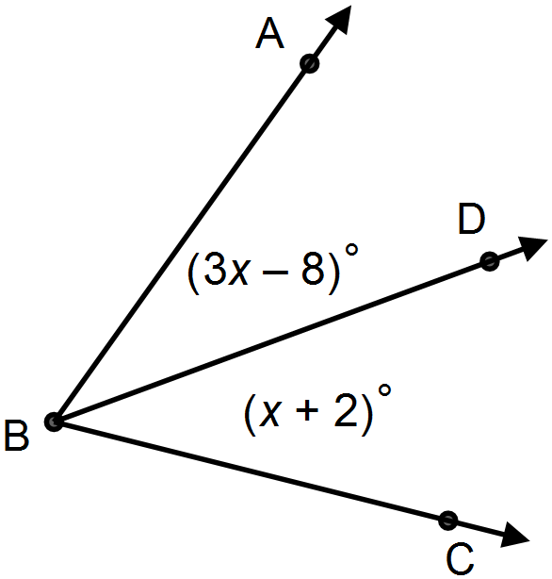

13. bisects $∠ABC.$

a. Find the value of $x$.

b. Find the $m∠ABD$.

***Use the diagram to answer #14-16.***



14. Three non-collinear points

15. Name in another way.

16. are coplanar? (True/False)

17. Find the length of $\overline{HJ}$ (Hint: First solve for *x*).



$$\overline{HJ}=3x – 6$$

$\overline{JK}=3x+4$

$\overline{KH}=22$

Name __________________________

**1.3 Homework**

***For #1 – 2: Find the image of each ordered pair after the translation (x, y) (x + 5, y – 7).***

1. 2.

__________ __________

***For #3 – 4: Give the pre-image for each image and translation listed below.***

3. Image: *G’(-2,6)* when 4. Image: *H’(1,-2)* when

(*x*, *y*) 🡪 (*x* – 3 , *y* + 11) (*x*, *y*) 🡪 (*x* + 4, *y* +8)

__________ ___________

5. Segment $AB$ has coordinates $A(4,1$) and $B(11,5)$. Graph the pre-image, then use the transformation of (*x*, *y*) 🡪 (*x* – 2, *y* + 7) to find the image of the segment. Draw both segments on the graph.

__________

__________

6. A rigid motion does not change the ______________ or ______________ of a figure.

7. Which figures below are examples of rigid motion transformations: ______________

|  |  |
| --- | --- |
| a) | b) |
| c) | d) |

***#8-9: Find the coordinates of each vertex after the given translation. Then graph the translation.***

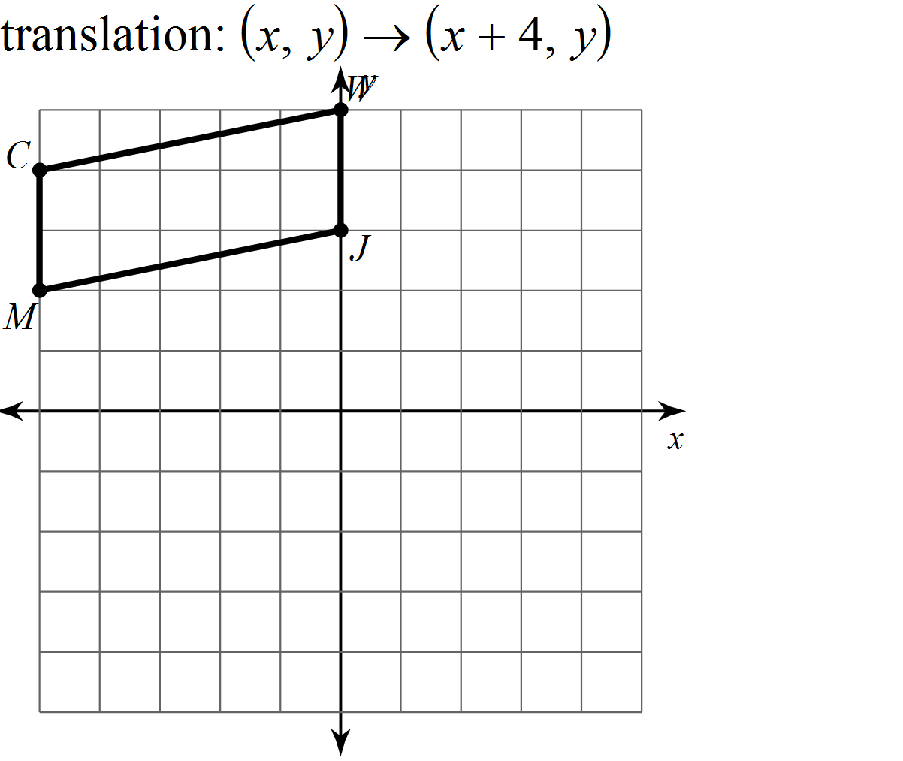

8. __________

__________

__________

__________

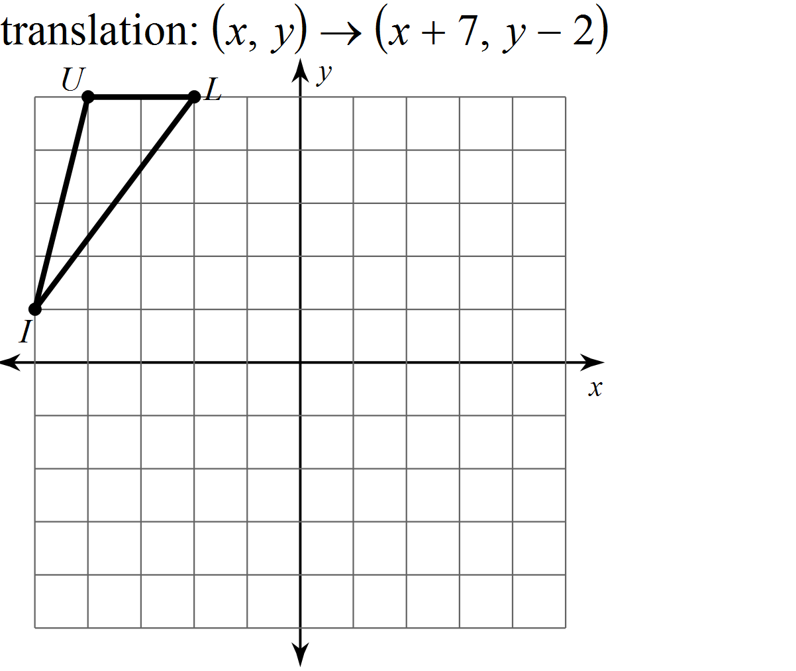

9. __________

__________

__________

***#10-11: Graph each transformation.***

10. 11.

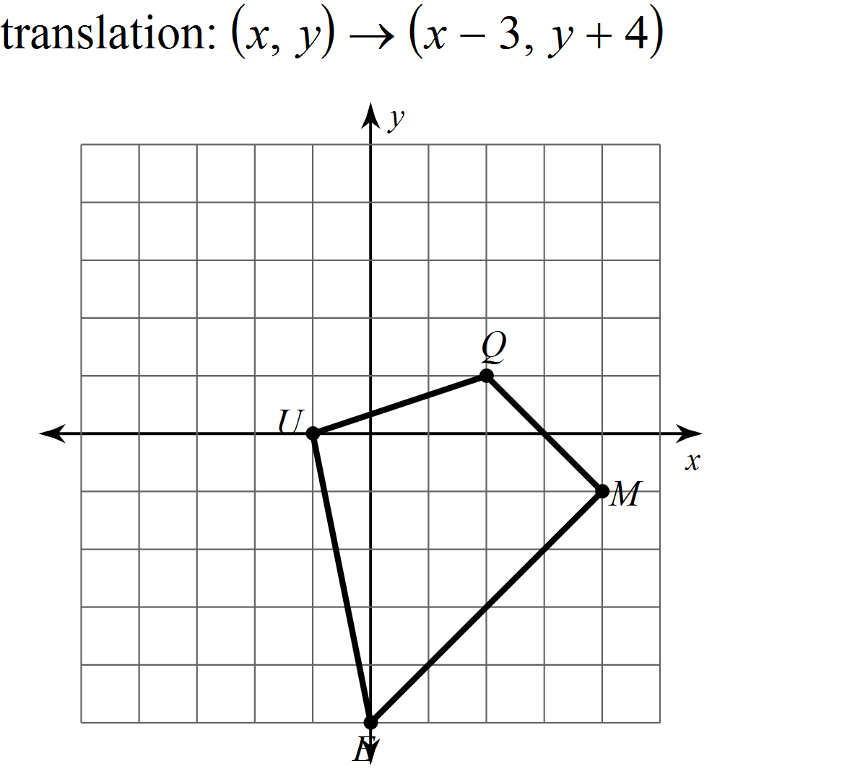 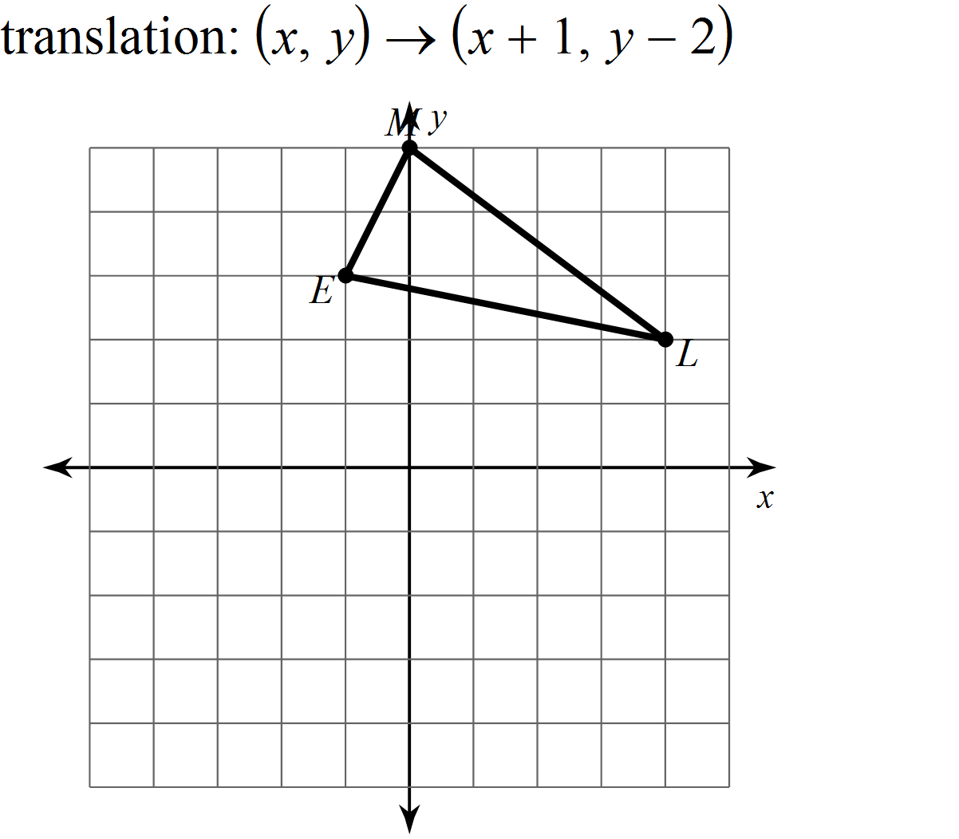

***REVIEW***

***Solve each equation.***

12. 13. 14.

15. Point is between points $X \& Z$ on $\overline{XZ}$. Find the value of $a$& the length of $\overline{XY}$ if

$\overline{XY}=3a, \overline{XZ}=5a-4, \& \overline{YZ}=14$.

Name __________________________

**1.4 Homework**

***Give the image of each point after a reflection across the given line. Use the graphs below to help you find the image points.***

|  |  |  |  |  |
| --- | --- | --- | --- | --- |
| 1. $R(3,1)$; x-axis |  | 2. $A(-6,-3)$; y-axis |  | 3.; |
|  |  |  |  |  |
| 4; |  | 5. |  | 6; |
|  |  |  |  |  |

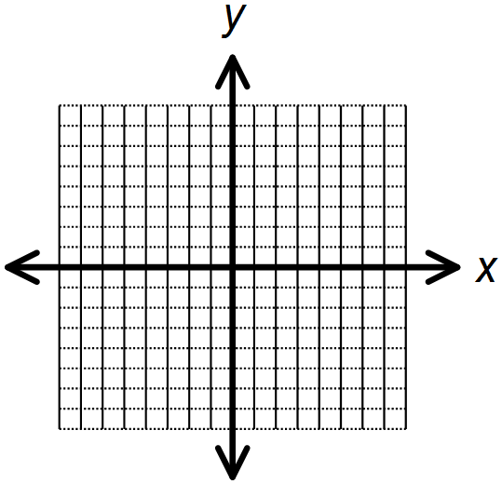





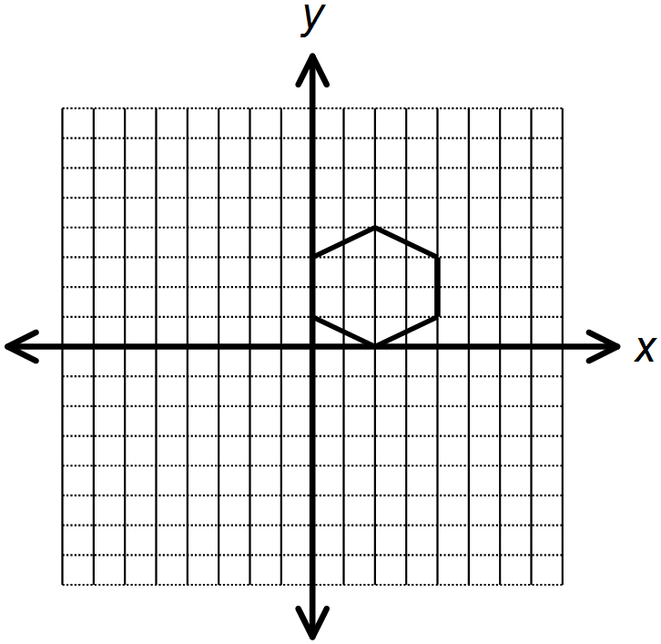

7. As the first step in designing a logo, you draw the figure

shown in the first quadrant of the coordinate plane.

Then you reflect the figure across the x-axis. You complete

the design by reflecting the original figure and its image

across the y-axis. Draw the completed design.

***Transform the pre-image below. Draw the resulting image.***

8. 9.

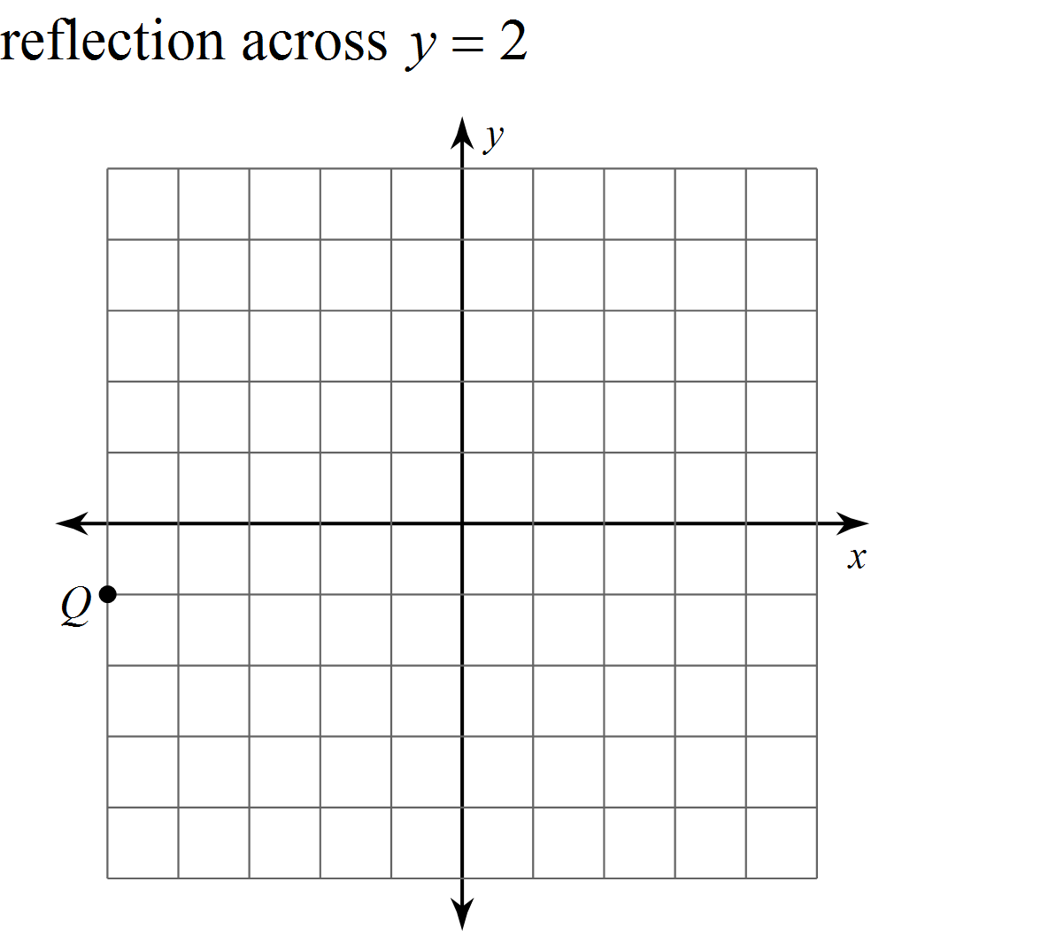 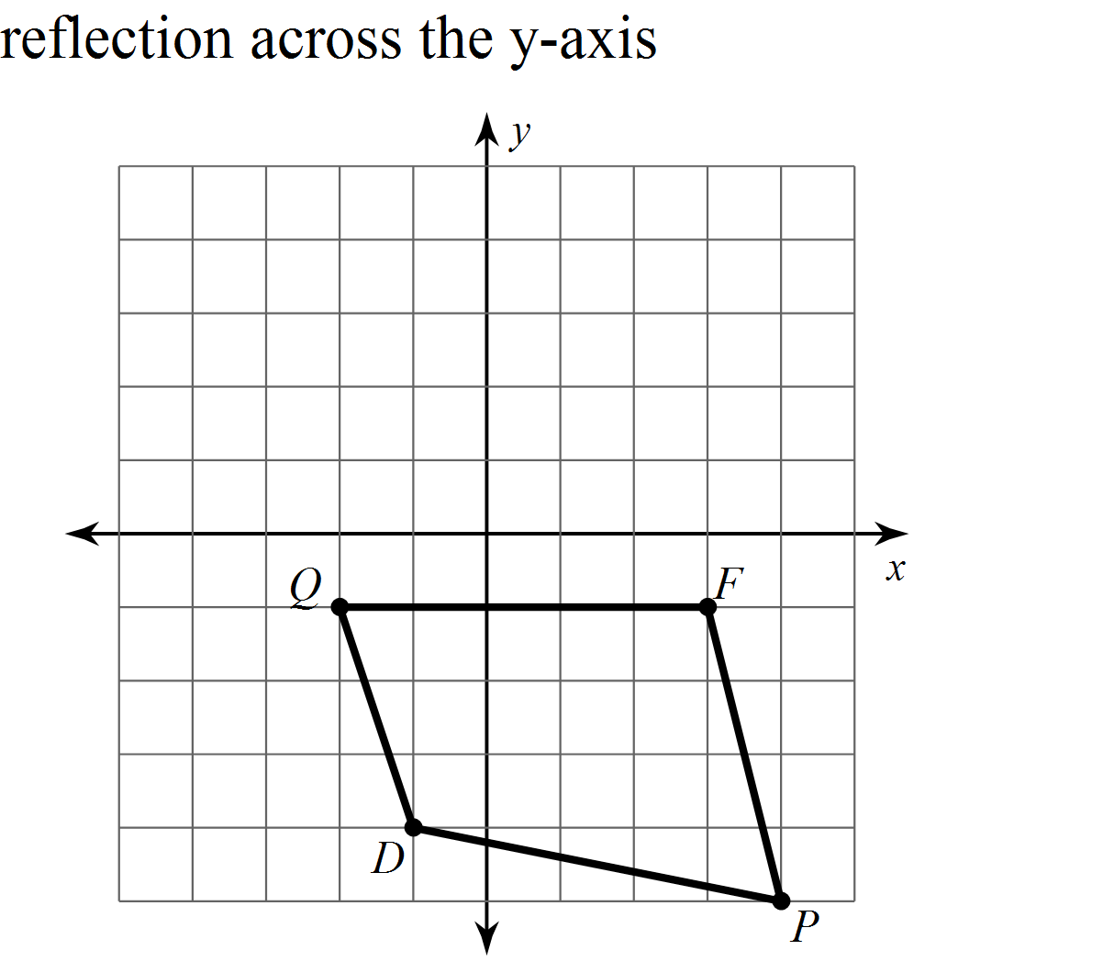

10. 11.

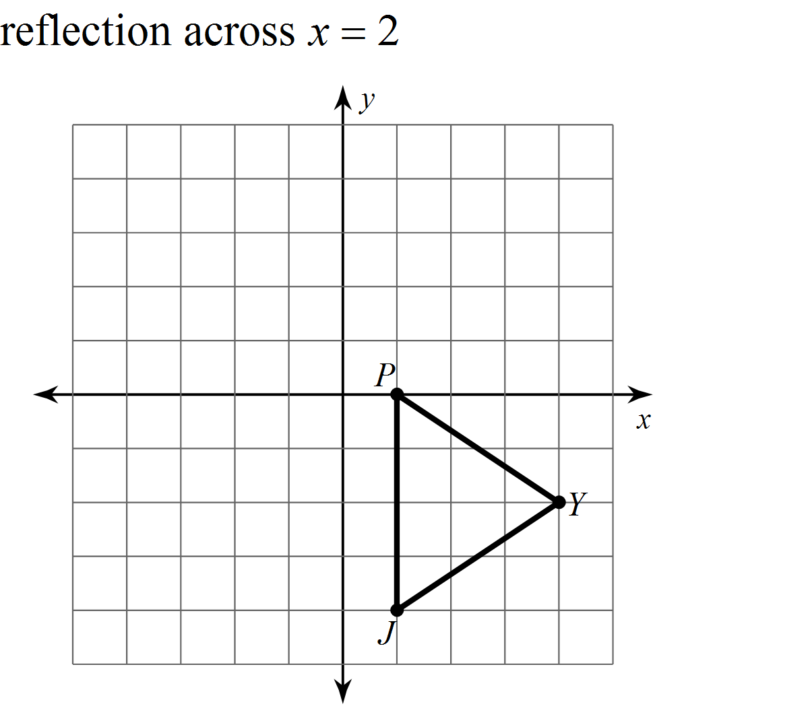 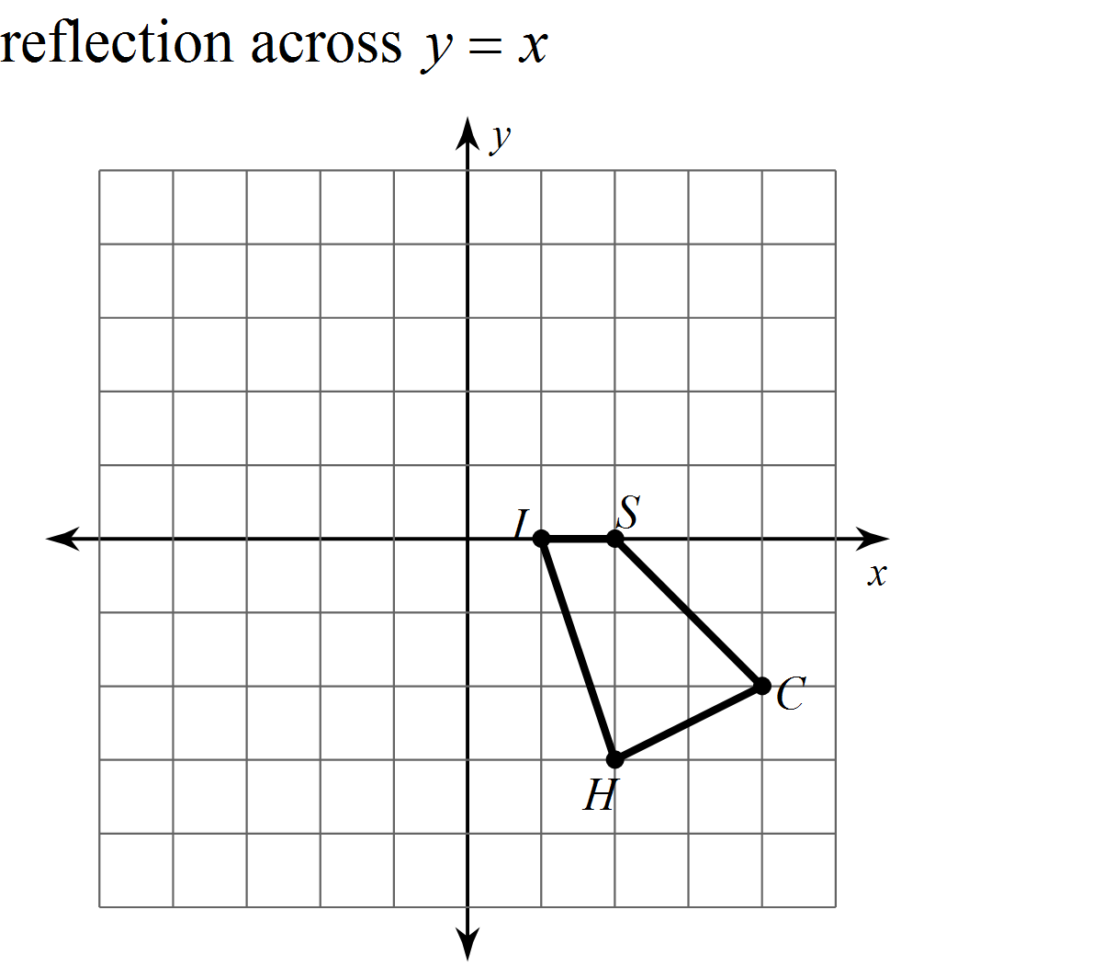

Translate $(x, y)→(x+2, y+1)$& reflect across $y=1$

Reflect over the $x-axis$& then translate &

12. 13.

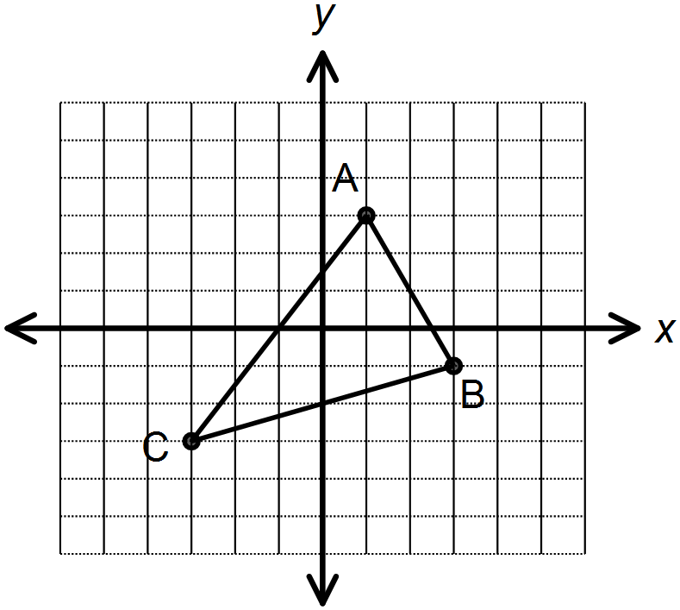

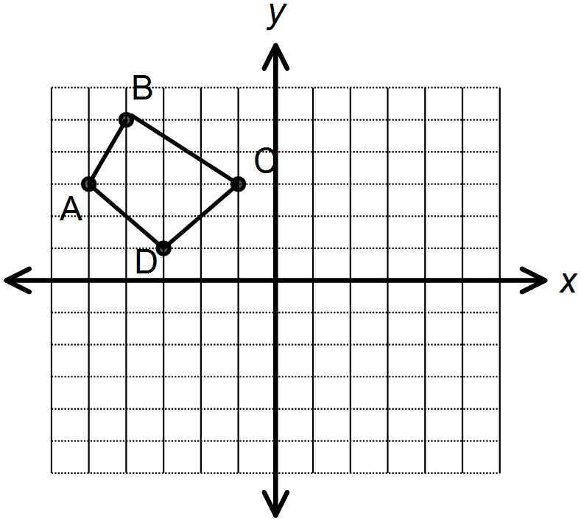

***REVIEW***

***#14-16: Use the diagram at the right.***

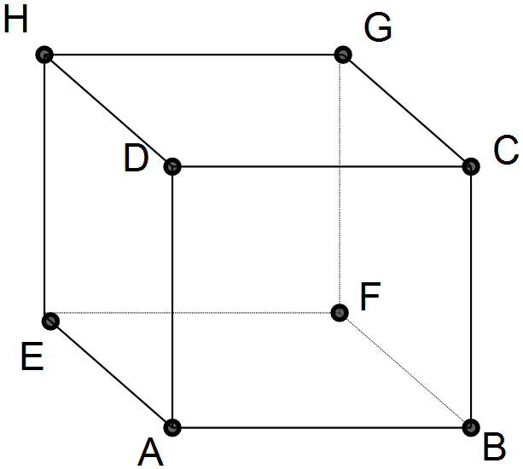

14. Name the intersection of planes

15. Will planes ever intersect?

16. Name two planes that will intersect at $\overset{⃡}{AB}$.

***#17-18: Use the angle at the right. $\vec{BD}$* bisects .**

17. If

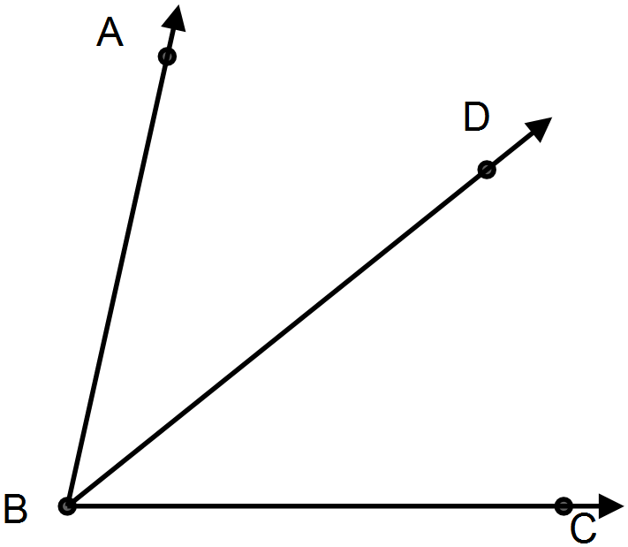

Find the measure of .

18. If

Find the measure of $∠ABD$.

Name __________________________

**1.5 Homework**

***#1-4: Draw the given rotation for each figure.***

1. 2.

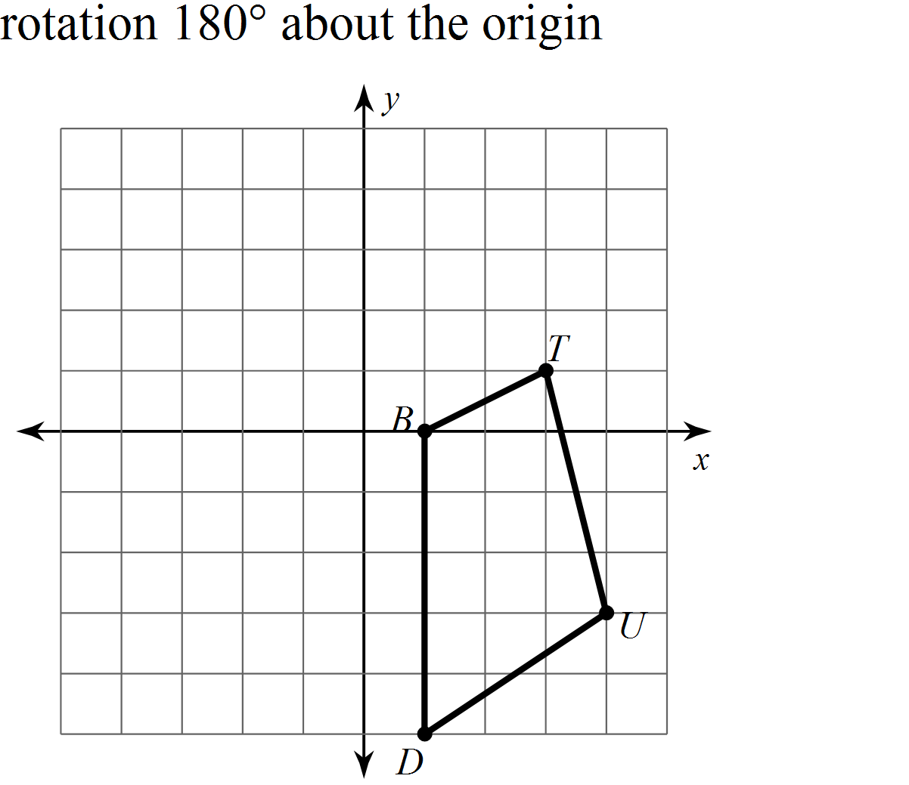

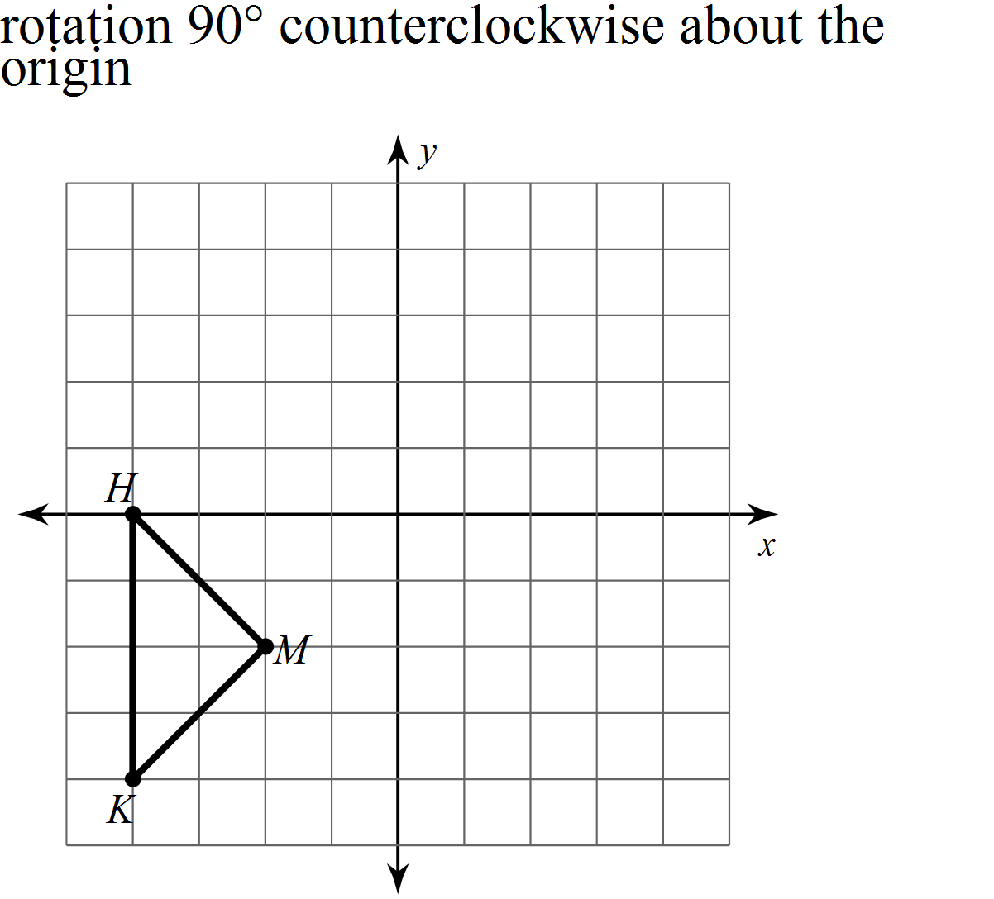

3. 4.

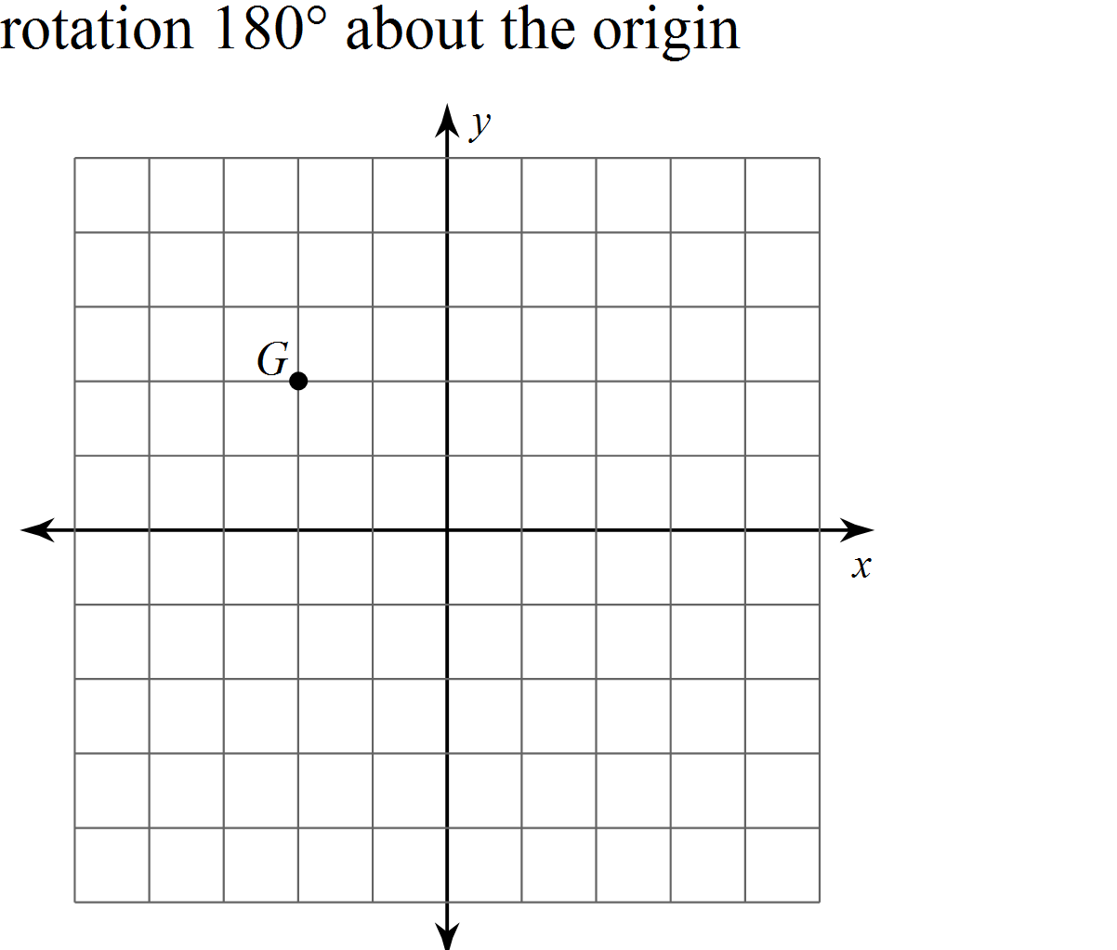

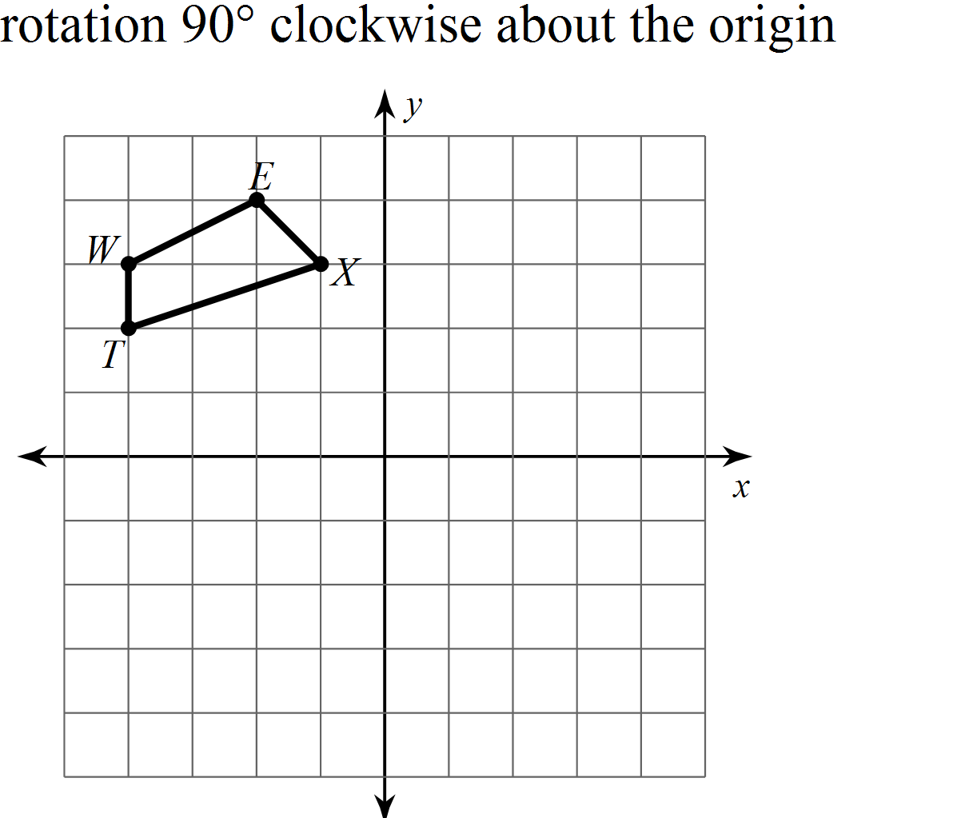

5. What are the coordinates for the image of $∆COW$ after a

rotation 90° counterclockwise about the origin and a

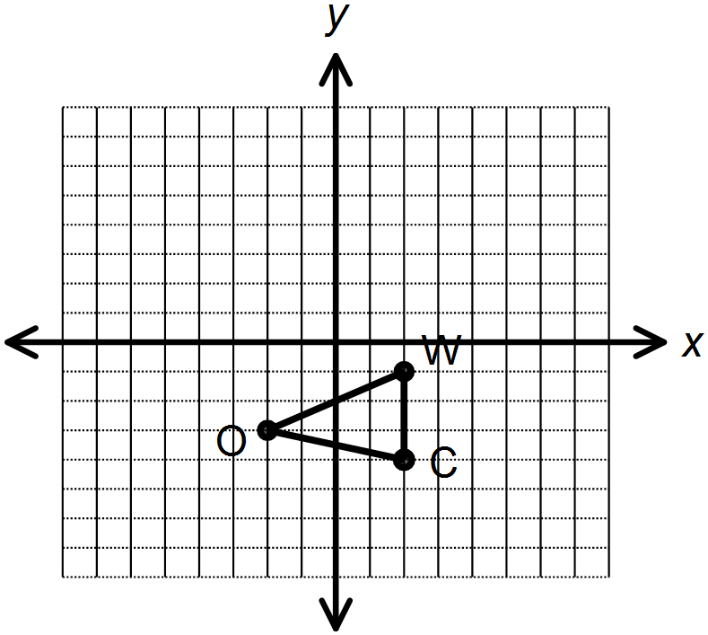

translation of ?

= __________

= __________

= __________

6. The point $P(-2,-5)$ is rotated 90° clockwise about

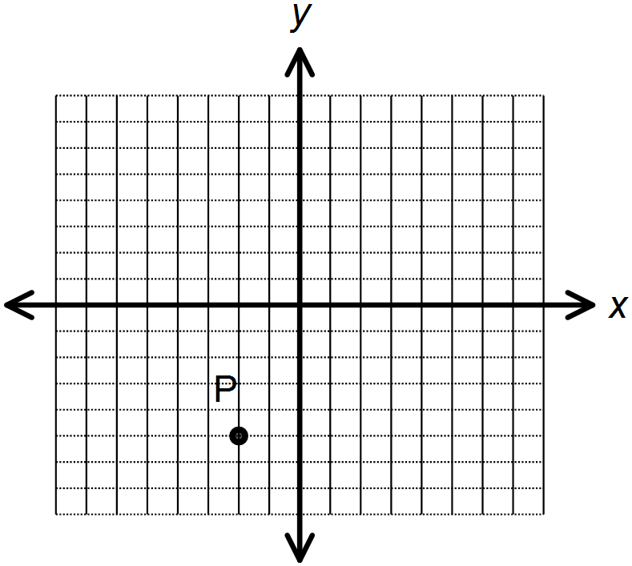

the origin, and then the image is reflected across the

line $x=3$. What are the coordinates of the final image P’?

= _____________

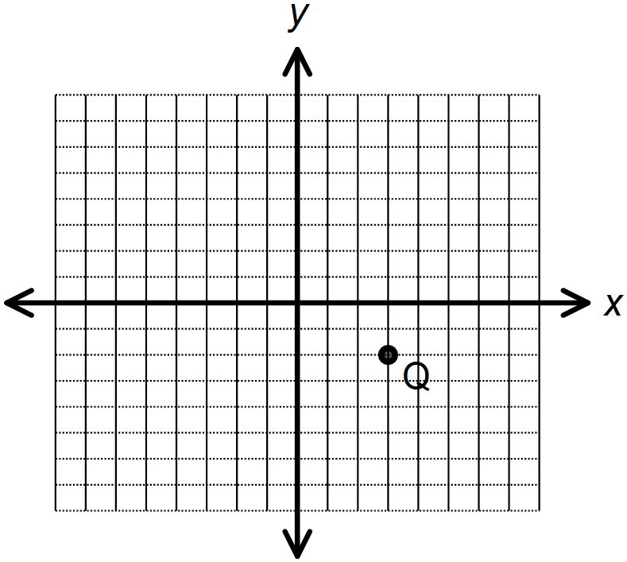

7. The point $Q(3, -2)$ is translated by $(x,y)⟶(x-2,y+1)$,

rotated $180$ ° counterclockwise, and finally reflected across

the $x-axis$. What are the coordinates of the final image Q’?

$Q’$ = _____________

***Follow the directions below to transform the figures. Draw the images on the graphs.***

8. Rotate $90$ ° clockwise, translate $(x,y)⟶(x-2,y+2)$, and reflect across the.

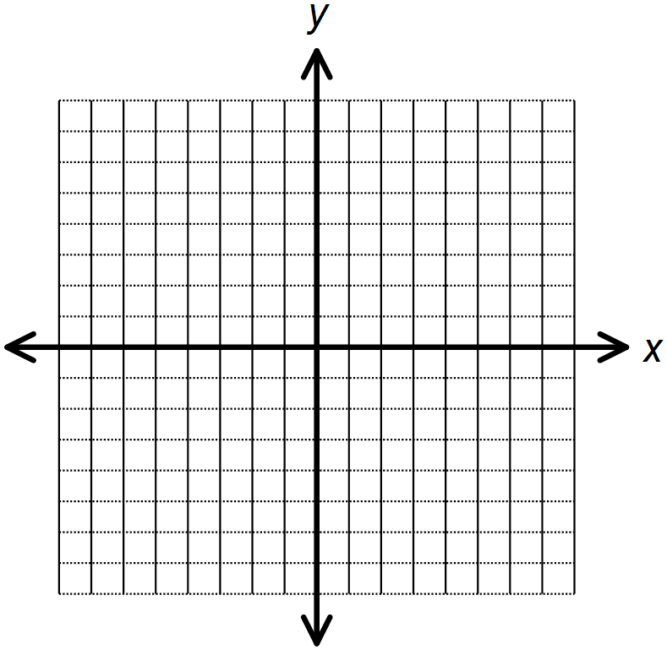



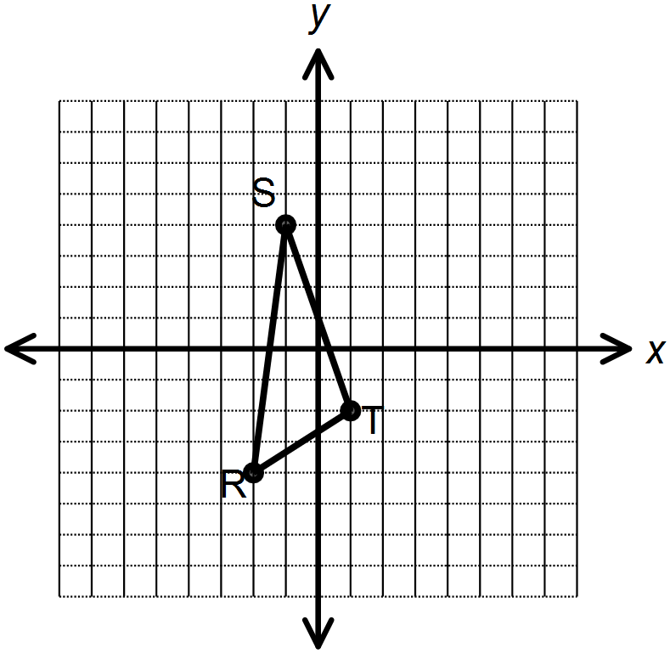

9. Rotate $180$ °, reflect across the line $x=-2$, and rotate again 90° counter-clockwise.

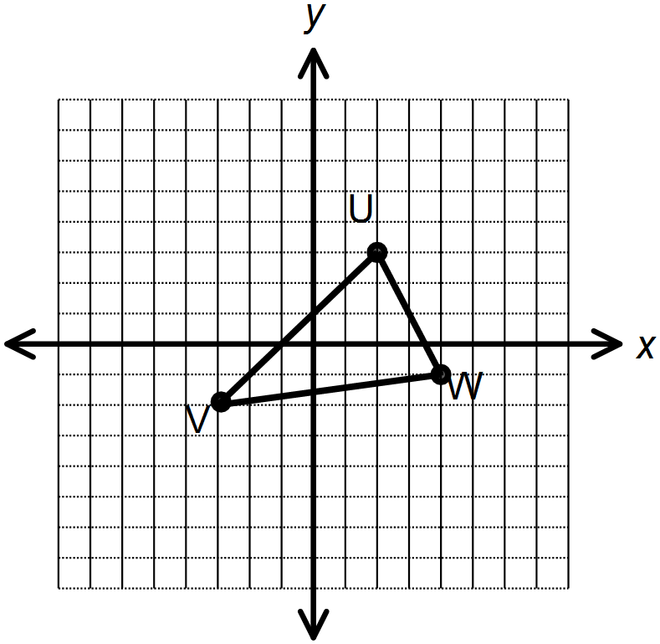





10. Translate $(x,y)⟶(x+1,y-2)$, reflect across the y-axis, and translate





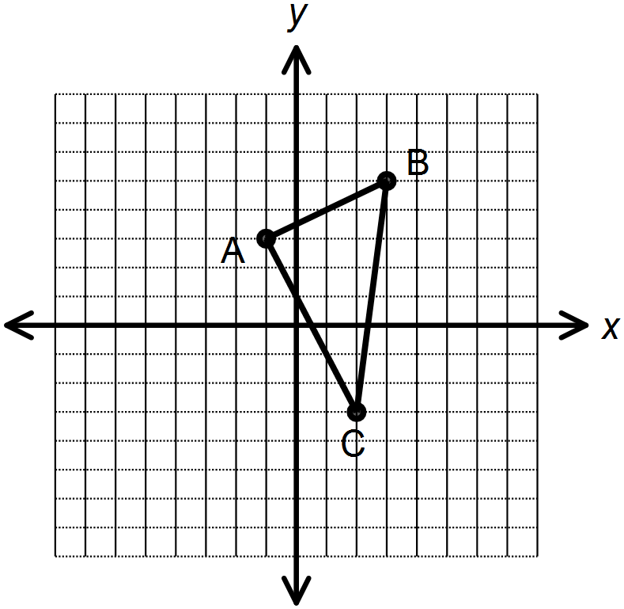



11. Reflect across the line $y=3$, rotate 270° clockwise, and translate





