Name _________________________

Unit 1: Practice Test

Date ____________ Period ________

*SHOW ALL WORK ON SEPARATE PAPER.*

*For # 1, know the definitions of the following terms.*

1. Collinear, Non-Collinear, Coplanar, Non-Coplanar, Congruent, Segment Bisector, & Angle, Bisector.

*For #2-5, draw an example of the following.*

2. Line 3. Ray 4. Segment 5. Angle

6. Draw a picture of five points A, B, C, D, E with the following requirements:

* A, B, and E are collinear
*  and  intersect at A
* C and E are collinear

A

C

B

F

E

H

G

D

J

K

***For #7-9, use the diagram at the right.***

7. Name a point that is collinear with A and B.

8. Name a point that is coplanar with D, C, and G.

9. Name a point that is coplanar with B, F, and D.

10. If and , find $AC$. 11. If AD = 39, find *x*.

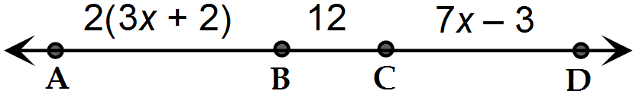



*For #12-14, draw a picture described in each question before answering the question.*

12. If line *m* bisects segment $DL$ at point $T$ and $DT=20$ and find .

13. is the angle bisector of $∠TEA$. Find the measure of $∠FEA$ and when.

14. bisects $∠ABC$. Find the value of $x$ and $m∠ABC$ when $∠ABD=6x°$ and

$∠DBC=(x+30)°$

For # 15 – 16, find the value of *x*.

15. 16.

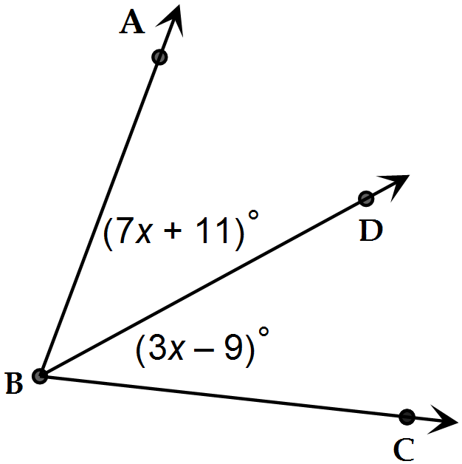

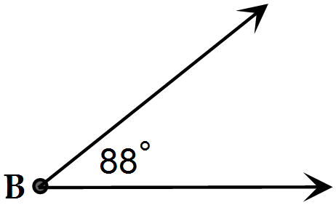

17. Name the angle in four different ways. 18. Draw an angle with the following points: M in on the interior, N & P are on the exterior, and Q is on the angle.

19. Find the image of $A(-5, 1)$ after the translation

20. Reflect $B(-2,-1$) across the $x$- axis. What are the coordinates of ?

21. Rotate the point $C(4, -5)$ $90°$ clockwise. What are the coordinates of ?

22. Point is reflected across the line $y=-1$. What are the coordinates of ’?

23. Point is reflected across $y=x$& then translated $(x, y)→(x-5, y-3)$. What are the coordinates of ?

24. Point is rotated $270°$ clockwise & then reflected across $x=2$. What are the coordinates of ’’?

25. Point translated $(x, y)→(x+5, y+3)$, and then reflected across the y-axis, & then rotated $180°$. What are the coordinates of

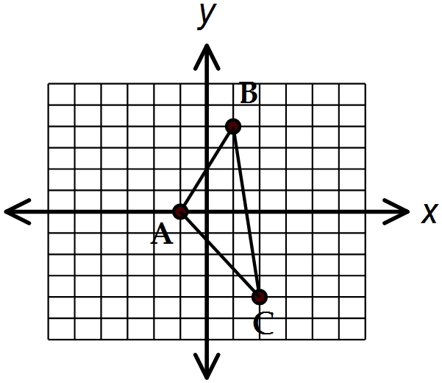

26. Find the coordinates of the vertices of the figure after a

reflection across the line $y=x$, and then a rotation of

$90°$ counter-clockwise.



27. Find the coordinates of the vertices of the figure after a

translation of $(x, y)→(x+2, y+1)$, a rotation of $180°$,

and then a reflection along the line .

28. Know how to construct a segment bisector, an angle bisector, a line perpendicular to a given line, & a circle. Know how to copy an angle & a segment.