Assignments for Geometry

Unit 2 Proofs Concerning Lines and Angles

|  |  |  |
| --- | --- | --- |
| **Day** | **Date** | **Assignment** (Due the next class meeting) |
| Wednesday  Thursday | 8/28/13 (A)  8/29/13 (B) | **Unit 1 Test**  **HW: Reading(Supp., Comp., and Vert. ∡’s)** **WS** |
| Friday Tuesday | 8/30/13 (A)  9/3/13 (B) | *Did you turn in your syllabus and pay your lab fee?*  Notes: 2.1 Bisectors  **HW: 2.1 Worksheet Bisectors** |
| Wednesday  Thursday | 9/4/13 (A)  9/5/13 (B) | *Did you turn in your syllabus and pay your lab fee?*  Notes: 2.2 Parallel Lines and Transversals  **HW: 2.2 Worksheet** **Parallel Lines and Transversals** |
| Friday  Monday | 9/6/13 (A)  9/9/13 (B) | *Did you turn in your syllabus and pay your lab fee?*  Notes: 2.3 Proofs  **HW: 2.3 Worksheet Proofs** |
| Tuesday  Wednesday | 9/10/13 (A)  9/11/13 (B) | *Did you turn in your syllabus and pay your lab fee?*  Notes: 2.4 (More Proofs)  **HW: 2.4 (More Proofs)** |
| Thursday  Friday | 9/12/13 (A)  9/13/13 (B) | *Did you turn in your syllabus and pay your lab fee?*  Notes: 2.5 (More Proofs)  **HW: 2.5 (More Proofs)** |
| Monday  Tuesday | 9/16/13 (A)  9/17/13 (B) | *Did you turn in your syllabus and pay your lab fee?*  Unit 2 Practice Test  **HW: Unit 2 Practice Test, HW Corrections** |
| Wednesday  Thursday | 9/18/13 (A)  9/19/13 (B) | **Unit 2 Test**  **HW: Congruence of Triangles Basics** |

**NOTE: You should be prepared for daily quizzes.**

HW reminders:

* If you cannot solve a problem, get help **before** the assignment is due.
* Help is available before school, during lunch, or during IC.
* For extra practice, visit [www.interactmath.com](http://www.interactmath.com), or khanacademy.org

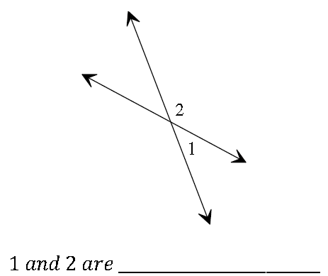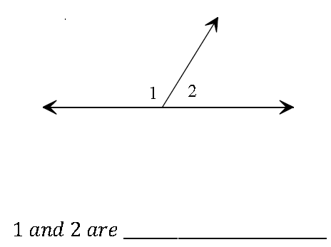Geometry: Complementary, Supplementary and Vertical Angels WS Name_________________________________

1. 2.

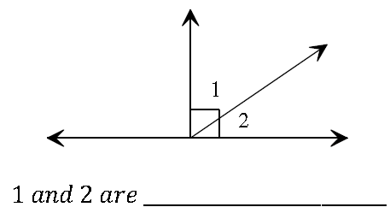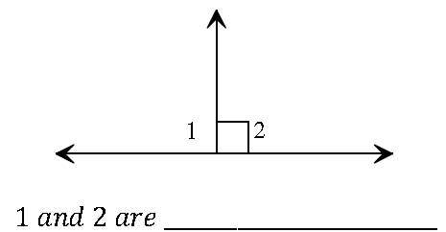

3. 4.

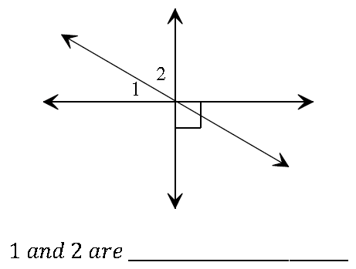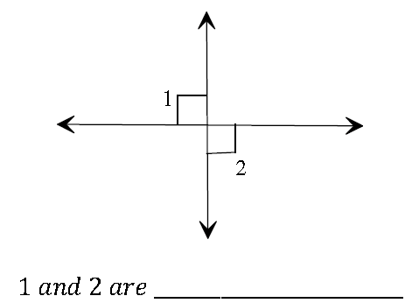

5. 6.

Write the value of the missing angles.

65°

25°

7. 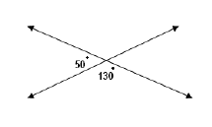 8.

9. Find the value of x in the diagram below. 10. The sum of any two angles that form a

linear pair is ___________.

10x-25

2x-15

Classify each angle measure below as acute, right, obtuse, or straight.

11. 75° 12. 125° 13. 180° 14. 90° 15. 15° 16. 91°

Geometry: 2.1 Worksheet Name________________________________

Solve for x using the angle bisector theorem in each diagram.

1. 2.

S

Q

11x-45

6x

2x-15

Q

3x-22

S

3. Draw a sketch of $\overline{QR}$ with perpendicular bisector of $\overset{⃡}{ST}$. What can be said about $\overline{SR}$ and $\overline{SQ}$? Explain.

Solve for x in the following diagrams given $\vec{QS}$ is the perpendicular bisector of the segment.

4. 5.

Q

x+12

Q

S

5x

3x

S

4x-1

S

6. 7. Use the Pythagorean Theorem.

5

4

S

Q

Q

(4x)°

x

8. Find the error: Claudio says that from the information supplied in the diagram below, he can conclude that K is on the perpendicular bisector of $\overline{LM}$. Caitlyn disagrees. Is either of them correct? Explain.

K

L

M

**Solve for x using the definition of angle bisector.**

9. AB bisects /XAY. 10. BD bisects / CBA. If m/CBA=75, then what is m/CBD?



11. The two angles below form a linear pair and are therefore supplementary. Solve for x.

(2x-13)°

(7x-68)°

12. Explain what an angle bisector means. Then sketch a picture of an angle that is bisected and label the angles that are congruent.

Review: ***Follow the directions below to transform the figures. Draw the images on the graphs.***

13. Rotate $90$ ° clockwise, translate $(x,y)⟶(x-2,y+2)$, and reflect across the.

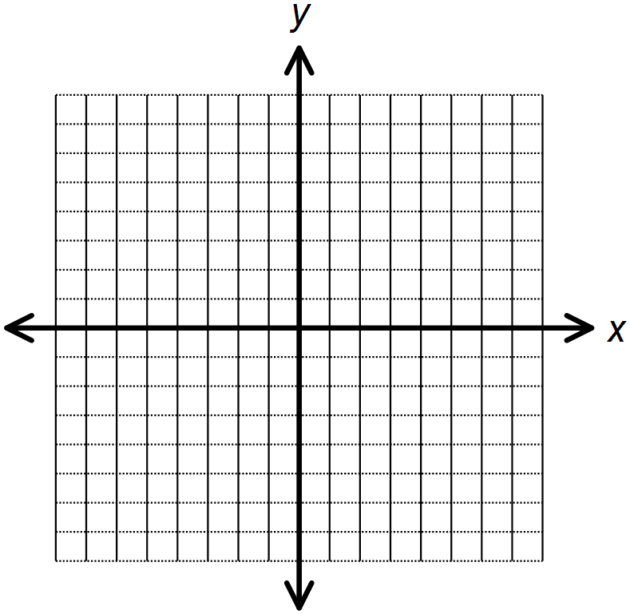



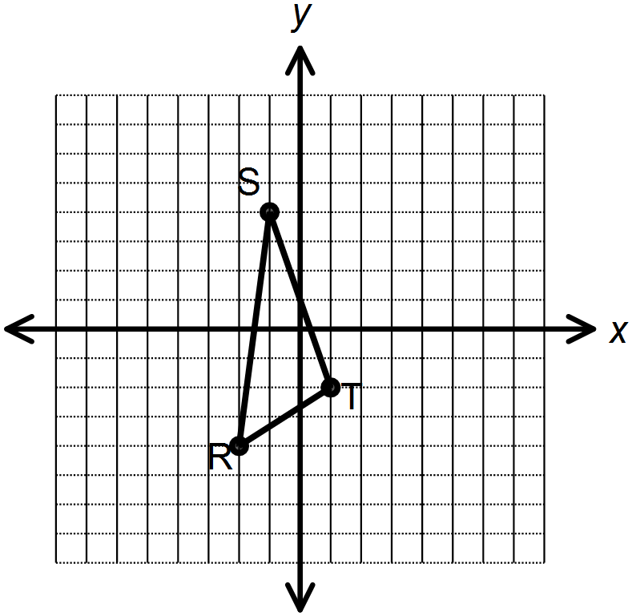

Geometry: 2.2 Worksheet Name________________________________

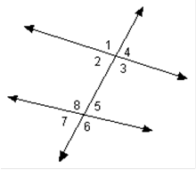Given: lines j and k are parallel. Find the missing angles if m∡3= 95°

1. m∡6=________

j

2. m∡7=________

k

3. Solve for x and y. 4. Solve for x

45

3x+8

128

5y



9x

5. Solve for x if m∡1= 4x and m∡2=88°

1

2

Use the diagram and given information to solve the following questions

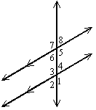Given: m∡8=4x

m∡4=2x+30

6. x=________

7. m∡6=________

8. Which angle is a vertical angle to ∡6?

9. Name one pair of consecutive interior angles.

10. Name one pair of alternate exterior angles.

For Questions 11-13, state the theorem that will prove the lines parallel if ∡1∡2.

11. 12. 13..

For questions 14-17, find the value of x so that the two lines cut by the transversal are parallel.

14. 15. 

3x

x

16. 17. 

Geometrty: 2.3 Worksheet Name________________________________

Complete each proof by filling in the missing reasons.

1. Given: $∠1$ is a right angle, $∠2$ is a right angle

2

1

Prove: $∠1≅∠2$

|  |  |
| --- | --- |
| Statements | Reasons |
| 1. $∠1$ is a right angle, $∠2$ is a right angle | 1. |
|  | 2. |

A

E

F

G

2. Given: Diagram as shown

B

D

Prove: $∠AGD≅∠EGB$

C

|  |  |
| --- | --- |
| Statements | Reasons |
| 1. Diagram as shown | 1. |
| 2. $∠AGD$ is a straight angle | 2. |
| 3. $∠EGB$ is a straight angle | 3. |
| 4. | 4. |

3. Given: ,

F

E

Prove: $∠CDE≅∠FGH$

H

C

G

D

|  |  |
| --- | --- |
| Statements | Reasons |
| 1. , | 1. |
| 2. | 2. |

4. Given: , ,

3

2

1

Y

Prove: $∠XYZ$ is a right angle

Z

x

|  |  |
| --- | --- |
| Statements | Reasons |
| 1. $∠1=20°$, $∠2=40°$, $∠3=30°$ | 1. |
| 2. $∠1+∠2+∠3=20°+40°+30°=90°$ | 2. |
| 3. $∠1+∠2+∠3= ∠XYZ$ | 3. |
| 4. $∠XYZ=90°$ | 4. |
| 5. $∠XYZ$ is a right angle | 5. |

5. The square has a perimeter of 42.

x + 3

a. Solve for x.

b. If the perimeter were greater than 42, what would we know about the value of x?

6. Point P has a coordinate of 7 on a number line. If you “slide” P 15 units in the negative direction, what is the new coordinate of the resulting point P’?

7. Follow the directions below and answers the following questions.

a. Draw a number line, labeling points A = -1, and B = 5. Then label point A’, the reflection of A over B.

b. Does AB = BA’?

c. What do we know about point B?

Geometry: 2.4 Worksheet Name________________________________

1. ***Proof of Theorem 3.1 (Alternate Interior Angles Theorem):***

***If $∥$*  ***lines, then alt. int. $∠^{'}s≅$.***

$$a$$

*Given: $a∥b$*



$$b$$

*Prove: $∠2≅∠3$*

|  |  |
| --- | --- |
| Statements | Reasons |
| 1. $a∥b$ | 1. |
| 2. $∠1≅∠2$ | 2. Vertical angles are congruent |
| 3. $∠1≅∠3$ | 3. |
| 4. $∠2≅∠3$ | 4. Transitive |

1. ***Proof of Theorem 3.2 (Consecutive Interior Angles Theorem):***

*If $∥$*  ***lines, then consec. int. $∠^{'}s$ are supplementary.***

$$a$$



*Given: $a∥b$*



$$b$$

*Prove: $∠2 is supplementary to ∠3$*

|  |  |
| --- | --- |
| Statements | Reasons |
| 1. $a∥b$ | 1. Given |
| 2. $∠1$ and $∠2$ are a linear pair | 2. Diagram |
| 3. $∠1 is supplementary to ∠2$ | 3. |
| 4. $∠1≅∠3$ | 4. Corresponding Angles are congruent |
| 5. $∠2 is supplementary to ∠3$ | 5. |

1.   *Given: $\overline{AD}∥\overline{BC}, ∠1≅∠2$*



*Prove: $∠2≅∠3$*

|  |  |
| --- | --- |
| Statements | Reasons |
| 1. $\overline{AD}∥\overline{BC}, ∠1≅∠2$ | 1. Given |
| 2. $∠1≅∠3$ | 2. |
| 3. $∠2 ≅∠3$ | 3. |

1. ***Proof of Theorem 3.8 (Perpendicular Transversal Converse):***

$$t$$

 *If 2 lines in a plane are $⊥$ to the same line, then they are $∥$.*

1

$$a$$

*Given: $a⊥t , b⊥t$*

2



$$b$$

*Prove: $a∥b$*

|  |  |
| --- | --- |
| Statements | Reasons |
| 1. $a⊥t , b⊥t$ | 1. Given |
| 2. | 2. Definition of perpendicular |
| 3. $∠1≅∠2$ | 3. |
| 4. $a∥b$ | 4. |

**

1. *Given: $\overline{AB}∥\overline{CD}, ∠1≅∠4$*

*Prove: $\overline{AD}∥\overline{BC}$*

|  |  |
| --- | --- |
| Statements | Reasons |
| 1. $\overline{AB}∥\overline{CD}, ∠1≅∠4$ | 1. Given |
| 2. | 2. |
| 3. | 3. Transitive/Substitution |
| 4. $\overline{AD}∥\overline{BC}$ | 4. |

1. **Given: $\overline{VW}≅\overline{AB}$** , $\overline{WX}≅\overline{BC}$, X is the midpoint of $\overline{VZ}$, and C is the midpoint of $\overline{AD}$

**Prove**: $\overline{XZ}≅\overline{CD}$

Z

X

W

V

D

C

B

A

|  |  |
| --- | --- |
| Statements | Reasons |
| 1. $\overline{VW}≅\overline{AB}$, $\overline{WX}≅\overline{BC}$ | 1. Given |
| 2. $\overline{VX}≅\overline{AC}$ | 2. |
| 3. X is the midpoint of $\overline{VZ}$, and C is the midpoint of $\overline{AD}$ | 3. Given |
| 4. $\overline{VX}≅\overline{XZ}$ and $\overline{AC}≅\overline{CD}$ | 4. |
| 5. $\overline{XZ}≅\overline{CD}$ | 5. |

Geometry: 2.5 Worksheet Name________________________________

1. Given: m∠1 = 400, m∠2 = 500, ∠3 comp ∠4, ∠1≅ ∠3

Prove: ∠2 ≅∠4

|  |  |
| --- | --- |
| **Statements** | **Reasons** |
| 1. | 1. |
| 2. | 2. |
| 3. | 3. |
| 4. | 4. |
| 5. | 5. |

2. Given:

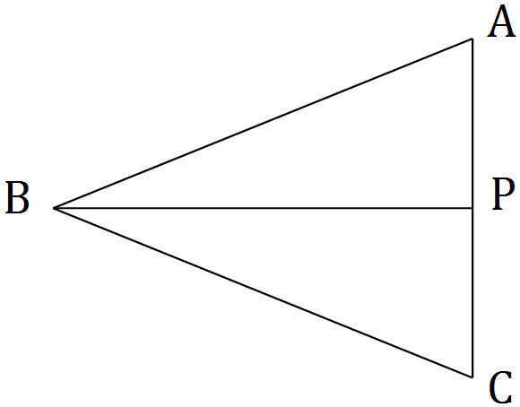

Prove: $\overline{AB}≅\overline{CB}$

|  |  |
| --- | --- |
| **Statements** | **Reasons** |
| 1. | 1. |
| 2. | 2. |
| 3. | 3. |
| 4. | 4. |

3. Given: , , ABE DCE



Prove: EBCECB

|  |  |
| --- | --- |
| **Statements** | **Reasons** |
| 1. | 1. |
| 2. | 2. |
| 3. | 3. |

**6. Fill in the following proof with the answer choice below**:

1

2

3

A

B

C

D

**Given: $\vec{DB}$** bisects $∡$ ADC

**Prove: $∡2 ≅ ∡3$**

|  |  |
| --- | --- |
| **Statements** | **Reasons** |
| 1. $\vec{DB}$ bisects $∡$ ADC | 1. Given |
| 2. $∡1 ≅ ∡2$ | 2. |
| 3. $∡1 and ∡3$ are vertical angles | 3. Definition of Vertical Angles |
| 4. | 4. Vertical Angles are Congruent |
| 5. $∡2 ≅ ∡3$ | 5. |

**Use the following answer choices (a) – (g) to fill in the proof above:**

**a. $∡1 ≅ ∡3$** **b. $∡2 ≅ ∡3$** **c**. $∡1 ≅ ∡2$**d**. Vertical Angles are Congruent

**e.** Substitution/Transitive **f**. Definition of Linear Pair **g**. Definition of Angle Bisector

**7**. **Given**: $p∥q$

**Prove**: $m∠1=m∠5$

|  |  |
| --- | --- |
| Statements | Reasons |
| 1. $p∥q$ | 1. Given |
| **2.** | 2. Alternate Interior Angles Theorem |
| 3. $m∠1=m∠3$ | 3. Vertical Angles Congruent |
| 4. $m∠1=m∠5$ | 4. Substitution property of equality |

**Choose one of the following to complete the proof.**

A. $m∠4=m∠6$ B. $m∠2=m∠8$

C. $m∠3=m∠6$ D. $m∠3=m∠5$

**Solutions:**

2.3

Given, Substitution, Angle Addition, Angles with the same measure are congruent, All right angles are 90°,

Substitution/Transitive, All straight angles are congruent, All right angles are congruent, Diagram,

2.4

Linear pairs are supplementary, Substitution, If two lines are parallel, the alternate interior are congruent,

Alternate Interior Angles are congruent, Segment Addition, $∠1≅∠2$, Definition of Midpoint

Transitive, $∠1$ and $∠2$ are right angles, All right angles are congruent, Corresponding Angles are congruent,

$∠2≅∠4$, Given, If the corresponding angles are congruent, then the lines are parallel,

Substitution/Transitive, If corresponding angles are congruent, then the lines are parallel,

2.5

1. m∠1 = 400, m∠2 = 500, ∠3 comp ∠4, ∠1≅ ∠3, Angles complementary to the same angle are congruent, Given,

Congruent angles are complementary to the same angle, ∠1+∠2=400 + 500 = 90°, Angle Addition, ∠2 ≅ ∠4

Definition of complementary, ∠1 and ∠2 are complementary, ∠1 and ∠4 are complementary,

2. , Diagram, $\overline{AB}≅\overline{CB}$, Given, Definition of $⊥$ bisector, B is on the $⊥$ bisector, $\overline{BP}$ is a $⊥$ bisector

$⊥$ Bisector Theorem

3. Angles complementary to ≅ angles are ≅, $∠ABE$ ≅ $∠ECB$, Given, , , ABE DCE,

$∠ABE$& $∠EBC$ are complementary $∠DCE$& $∠ECB$ are complementary, Definition of complementary